119. Pascal's Triangle II

Easy
4.5K
316

Companies
Given an integer rowIndex, return the rowIndexth (0-indexed) row of the Pascal's triangle.
In Pascal's triangle, each number is the sum of the two numbers directly above it as shown:
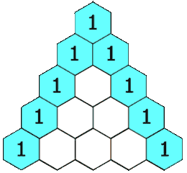

Example 1:
Input: rowIndex = 3
Output: [1,3,3,1]
Example 2:
Input: rowIndex = 0
Output: [1]
Example 3:
Input: rowIndex = 1
Output: [1,1]

Constraints:
- 0 <= rowIndex <= 33

Follow up: Could you optimize your algorithm to use only O(rowIndex) extra space?

